**III-Install Docker and Kubernetes on the cluster.**

**A**fter many tries, I had successfully installed my Kubernetes cluster on EC2 using kops.

Here are the steps.

I will also provide with the GitHub link.

https://github.com/jeanmd1/k8sonEC2.git

Launch an EC2 amazon Linux server t2 micro

Configure security group with all allow inbound

Create a role with admin permissions

Role attached

Route 53 create

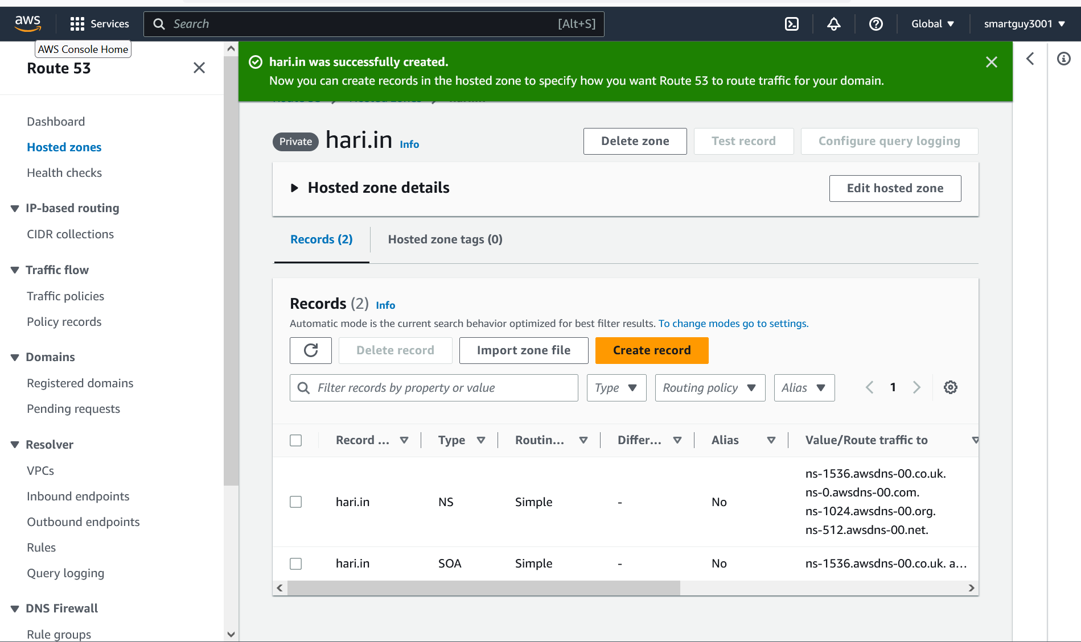

Connection to my EC2 using MobaXterm.

Install kops with appropriate permissions.

Install Kubernetes and all permissions.

Create s3 bucket.



Edit ~/.bashrc with export KOPS ClUSTER NAME and KOPS_STATE_STATE s3 bucket

Generate keys pairs.

Kops started creating cluster.

Creating Cluster confirmation

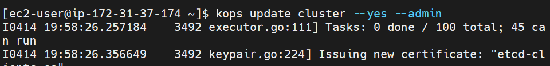

Creation Cluster in progress

Cluster ready to use.

Verification on EC2 Dashboard.

Let’s see our cluster.

